## NAME:S.Logitha

REG NO:192121138

**17.USING RAPTOR –DISPLAY PRIME NUMBERS BETWEEN 1 AND 100**

**FLOWCHART**

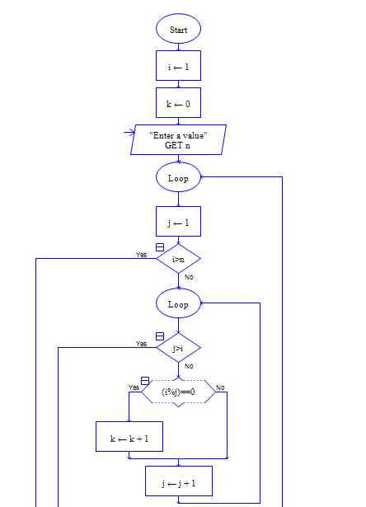

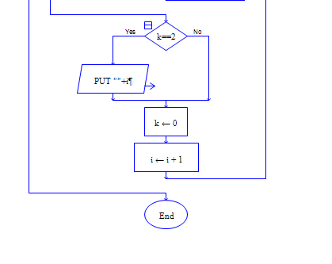

**INPUT**

100

**OUTPUT**

